Masarykova univerzita
Fakulta informatiky

California Digital Library (CDL)
PV070 Digitální knihovny

Anastasia Korovina
Ročník 1, UČO 436377

Brno, 5. prosince 2014

Introduction
The California Digital Library (CDL) was founded in 1997 by the University of California (UC). CDL collaborates with the UC libraries and other partners like the University of Washington, the University of Oregon, the University of Arizona. The UC Libraries are also currently taking part in two projects focused on mass digitization - Google Book Search project, and digitization performed by the Internet Archive. Working in partnership with university's libraries and campuses allowed them to bring the treasures of libraries, museums, and cultural heritage organizations to the world. Eventually CDL has managed to assembled one of the world’s largest digital research libraries.

History of project
In 1997 University of California President Richard C. Atkinson announced the foundation of the California Digital Library - "a service that will make it possible to bring to computer screens statewide the holdings of UC libraries and others throughout the world." The intention was to license, obtain, extend and manage all categories of digital content, such as books, magazines monographs and even photographs. The library's plan was also to set strategy and processes archiving its holdings.
The benefits of this started to appear one year later, when the University of California saved $2 million in a single year. This was possible thanks to system-wide licensing negotiated by CDL instead of separate campuses. The idea of CDL turned out to be very profitable for University of California as in 2002, $25 million was saved thanks to system-wide licensing.
In 2003, the discovery platform Melvyl was re-launch with impressive 23 million records.
Announcing partnership with Google to digitize books from the libraries’ collections in 2006 was another success of this project. "The books provided by university were scanned in a facility owned by Google and afterwards they were returned to libraries to make sure no books are damaged in the process of scanning."
In its history, CDL has established many programs (such as Digital Preservation Program, Shared Print initiative, EScholarship) on its own and taken part in many joint ventures (such as the HathiTrust, the Open Content Alliance) to successfully fulfill its mission.
Today, the CDL has a Digital Special Collections (DSC) program that tries to improve usability of Online Archive of California for its users and contributors. The DSC is constantly focused on improving site functionality and integrating collection guides and associated digital content.

Goals of the project

Mission of CDL is to connect students, faculty and staff of the University of California to make the research of publications simple for them by integrating and simplifying library systems. Using discovery platform Melvyl, CDL developed one of the biggest online library catalogs in the United States.

The main purpose of the project is to provide their users access to the huge print and online collections. It gives users reliable and seamless access to books and articles and it provides an opportunity to deliver library services to their homes, on the web or, for example, by using such popular sites as Google Scholar or PubMed.

The strategic aim of this project is integration of the widest possible range of contents with delivery tools and services and becoming an alternative to available commercial providers. In annual report for 2012-2013, the CDL's director stated that "they had achieved a significant overall goal by having over 20 services addressing all stages of the research life cycle".

Description of project

This project consists of two important parts. The first one covers information retrieval services and the other one represents publishing services.

The basic idea behind information retrieval services is to become a provider of various information from many different sources in an efficient and timely manner. Discovery and Delivery team of the CDL uses different tools and techniques in order to integrate library services and resources into CDL. This also provides easy access for end-users to reach content that would be otherwise available only through commercial information providers.

Information retrieval services

Melvyl

One of the most important services used by CDL is discovery platform Melvyl. This online library catalog used by CDL is the example of a attempt to revolutionize existing library catalog systems with modern information resources. Melvyl is powered by OCLC WorldCat Local and connects to the vast research world - today it's possible to search 800 million+ items from research institutions throughout the whole world.

During the development of Melvyl, lot of stress has been laid on improving user experience from using this catalog. Attention was paid also to improvements of recommendation algorithms. This includes features like relevance ranking, auto-correction, use of a text-based discovery system and user interface strategies. Specialty of the system is ability to utilize both keyword similarities and using historic resource circulation data in order to make recommendations smarter and educated form other user's data.

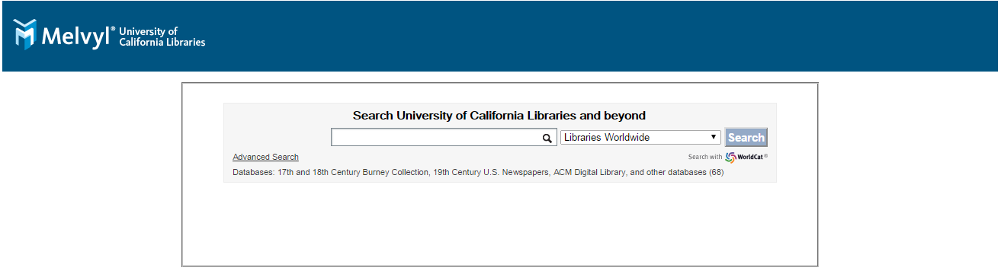

UC-eLinks

The feature called UC-eLinks, that exists since 2002 and runs on SFX software from Ex Libris, allows to insert button into library catalogs, various databases, citation programs and citations of publications. This button then immediately mediates access to the associated publication or request access in the case of print-only resources.

UC-eLinks has caused shifts in the way scholars doing their research. It managed to merge discovery and delivery into one process - researchers can access publications online in the same time they find them. This direct connection between scholars and publications also means you can instantly move from an article (book) citation to the actual publication.

Other UC-eLinks abilities are to let users check if an item is available in any of the UC libraries and ability to request print publications from other campuses. Moreover, UC-eLinks has provided a chance to analyze user's resource utilization and request patterns.



Publishing services

Another department of California Digital Library makes sure that all publishing efforts are effortlessly accessible by students, teachers and faculties of University of California. This department also holds the responsibility for increasing the number of sources, digitized prints and other useful resources.

eScholarship

eScholarship offers a way to all UC scholars how they can share their existing publications with audience all over the world. Nowadays, eScholarship hosts more than 70 000 publications with more than 20 million item views since its start.

By using eScholarship platform, University of California has full control over publications of its scholars. Also books or even conference proceedings can be stored there. Another important effect of this platform is that it helps to growth audience for new works and thus it motivates scholars to publish more researches.

The Online Archive of California

The Online Archive of California offers access via CDL to in-depth descriptions of primary resource collections for institutions that are affiliated with the University of California. Many organizations contribute resources just to be accessed, including libraries, special collections, archives and museums. Inside CDL, the OAC is managed by the Digital Special Collections Program. The meaning of the OAC is to provide UC scholars with easy access to very detailed descriptions of various pieces of work, often including valuable information like work's background, analysis, and historical context.

In Online Archive of California, there is free public access to primary sources —including many different types of content —through more than 38,000 collection guides and 200,000 digitized images and documents. The content on the Online Archive of California is made from more than 200 archives, special collections, libraries, historical societies, and museums at all 10 University of California campuses and across all California that house the original materials.

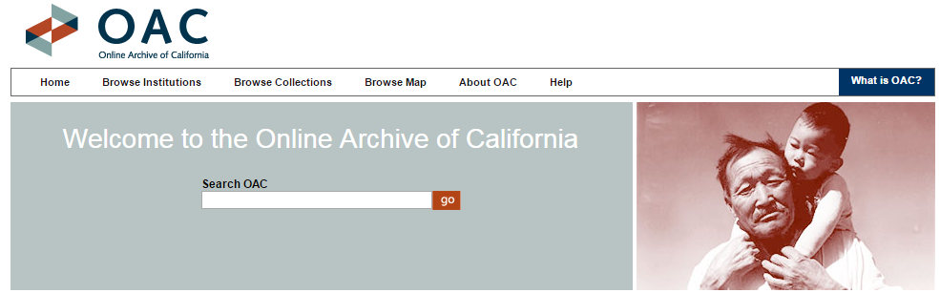

Personal evaluation of CDL project

I chose this topic because I was interested in CDL as one of the biggest aggregator of publications and related data. I find this project very interesting and also successful. My opinion about success of this project is based on number of publications and contents gathered on one place available for all scholars of University of California and also because of the millions of dollars it has saved to UC in 17 years of its existence by using co-investment and sharing of materials and services used by libraries across the UC system.

In this essay, I introduced four services that I find particularly interesting. Melvyl as discovery platform is very powerful because of sophisticated algorithms and it has promising future because CDL pays a lot of attention to it as it re-launched Melvyl a several times to create ultimate recommendation tool. UC-eLinks is very handy feature that makes searching for publications a lot easier, thus more effective. eScholarship is a good tool for supporting scholars from University of California and I think it can positively affect number of academic researches at UC. On the other hand, Online Archive of California provides detailed descriptions of many primary resource collections maintained by more 200 contributed organizations, which is useful for researchers.

Sources

http://www.cdlib.org/about/

http://melvyl.worldcat.org/

http://www.cdlib.org/about/mission.html

http://en.wikipedia.org/wiki/California_Digital_Library
- http://www.oac.cdlib.org/
- http://www.cdlib.org/services/d2d/ucelinks/
- http://www.escholarship.org/
- California Digital Library. "UC Libraries Mass Digitization Projects"
- http://www.cdlib.org/news/docs/CDLAnnualReport_2012_2013.pdf
- http://oclc.org/worldcat-local.en.html
- http://melvyl.worldcat.org
- http://webarchives.cdlib.org/sw1st7gf68/http://www.universityofcalifornia.edu/news/article/20579
- http://www.cdlib.org/news/docs/CDLAnnualReport_2012_2013.pdf

Metadata

TITLE=California Digital Library (CDL)

CREATOR=Anastasia Korovina

DESCRIPTION=Essay focused on California Digital Library (CDL), it describes the project itself and its goals, the most important services included in CDL and evaluation of the project.

SUBJECT.Keywords= California Digital Library, CDL, Melvyl, OAC, esScholarship, UC, UC-eLinks

DATE.Created=2014-12-05

LANGUAGE=english

FORMAT.Medium=application/doc

http://webarchives.cdlib.org/sw1st7gf68/http://www.universityofcalifornia.edu/news/article/20579
California Digital Library. "UC Libraries Mass Digitization Projects". Retrieved 5th of December 2014.
http://melvyl.worldcat.org
http://www.cdlib.org/news/docs/CDLAnnualReport_2012_2013.pdf
http://melvyl.worldcat.org/
http://oclc.org/worldcat-local.en.html
http://www.cdlib.org/services/d2d/ucelinks/
http://www.escholarship.org/
http://www.oac.cdlib.org/

